***OPAKOVANIE Name:***

***1. some, any, much, many, a lot of***

1. There aren't .....**many/much**.....Spodná časť formulára

car parks in the centre of Oxford.score

2. Eating out is expensive here. There aren't ...**any /some**... cheap restaurants.

3. Liverpool has **....a lot of/many...**great nightclubs.score

4. Hurry up! We don’t have ..**a lot of/much**.....time before the coach leaves.score

5. We saw ..... **a lot of / many**..... beautiful apples in the park.score

6. There are .....**many/any**....shops near the university.score

7. It's very quiet. There aren't ..**much/many**.......people here today.score

8. How ...... **many/much** ..... robots are there in Slovakia?

9. There are ......**many/some**......expensive new cars next to the river.score

10. How ....**much/many** .... rice do you eat daily?

11. Are there ......**some/any** ....potatoes?

12. No, there aren’t ..........**any/some**.

13. Are there....... **a lot of/many**.... sweets in the vending machine?

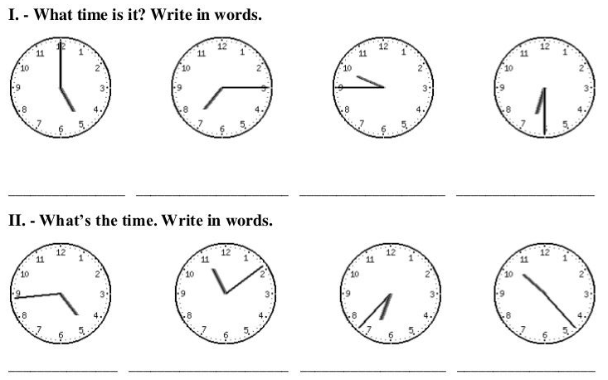

1. Please be quiet! I (work) now! 13. Ann often (play) tennis.
2. Listen! The  boy  (sing) a nice song. 14. She often (eat) meat.
3. It (not rain) at the moment.
4. This shop (open) at eight and (close) at six every day.
5. She always (go) to school by bike.
6. Pst! The baby (sleep) now.
7. Tom always (get up) early in the morning.
8. Look! Peter (jump).
9. They (have) their lunch at the moment.
10. Look! Somebody (swim) in the cold river.
11. What  you  (do) now? I (listen) to music!